SIMATS ENGINEERING

ASSESSMENT TOOL 1

COURSE NAME: Database Management Systems COURSE CODE: CSA05

COURSE OUTCOME COVERED
CO1: Analyze DBMS architecture, different data models, schema types, and design ER/EER diagrams, relational schemas for case-based scenarios by identifying entities and relationships. (BL1, BL2)

Activity Tool : Short Answer Text(High) Assessment Tool Weightage: 30%

Dr

QUESTIONS Total Marks: 50
Q.No | Question | Bloom's Level | Marks
1 | UPS Product Tracking Information System  UPS prides itself on having up-to-date information on the processing and current location of each shipped item. To do this, UPS relies on a company-wide information system. Shipped items are the heart of the UPS product tracking information system. Shipped items can be characterized by item number (unique), weight, dimensions, insurance amount, destination, and final delivery date. Shipped items are received into the UPS system at a single retail center. Retail centers are characterized by their type, uniqueID, and address. Shipped items make their way to their destination via one or more standard UPS transportation events (i.e., flights, truck deliveries). These transportation events are characterized by a unique scheduleNumber, a type (e.g, flight, truck), and a deliveryRoute. Create an Entity Relationship diagram that captures this information about the UPS system. | BL1 –  Remember | 5
2 | Course Management System  Consider a university database for the scheduling of classrooms for final exams. This database could be modeled as the single entity set exam, with attributes course-name, section-number, room-number, and time. | BL2 –  Understand | 5

Alternatively, one or more additional entity sets could be defined, along with relationship sets to replace some of the attributes of the exam entity set, as
- course with attributes name, department, and c-number
- section with attributes s-number and enrollment, and dependent as a weak entity set on course
- room with attributes r-number, capacity, and building
Show an E-R diagram illustrating the use of all three additional entity sets listed.
3 | University Registrar’s Office Management System  A university registrar’s office maintains data about the following entities:  - courses, including number, title, credits, syllabus, and prerequisites;  - course offerings, including course number, year, semester, section number, instructor(s), timings, and classroom;  - students, including student-id, name, and program;  - instructors, including identification number, name, department, and title.  - Further, the enrollment of students in courses and grades awarded to students in each course they are enrolled for must be appropriately modeled.  Construct an E-R diagram for the registrar’s office. | BL2 –  Understand | 5
4 | Hospital Management System  Construct an E-R diagram for a hospital with a set of patients and a set of medical doctors.  Associate with each patient a log of the various tests and examinations conducted. Construct appropriate tables for the above ER Diagram : Patient(SS#, name, insurance)  Physician ( name, specialization) Test-log( SS#, test-name, date, time)  Doctor-patient (physician-name, SS#) Patient-history(SS#, test-name, date) | BL2 –  Understand | 5
5 | Company Project Management System  Construct an ER Diagram for Company having following details :  Company organized into DEPARTMENT. Each department has unique name and a particular employee who manages the department. Start date for the manager is recorded. Department may have several locations.  - A department controls a number of PROJECT. Projects have a unique name, number and a single location.  - Company’s EMPLOYEE name, ssno, address, salary, sex and birth date are recorded. An employee is assigned to one department, but may work | BL2 –  Understand | 5

for several projects (not necessarily controlled by dept). Number of hours/week an employee works on each project is recorded; The immediate supervisor for the employee.
- Employee’s DEPENDENT are tracked for health insurance purposes (dependentname, birthdate, relationship to employee).
6 | Explain schema and instance with examples. Distinguish between logical schema, physical schema, and view schema. | BL1 –  Remember | 5
7 | Identify the entities, attributes, and relationships for a Bank Management System and construct its ER diagram. | BL2 –  Understand | 5
8 | Explain the Extended ER (EER) model. Describe the concepts of generalization, specialization, and aggregation. | BL2 –  Understand | 5
9 | Design an EER diagram for a Hospital Management System incorporating inheritance and weak entities. | BL2 –  Understand | 5
10 | Explain the role of a DBA (Database Administrator) and the responsibilities associated with the position. | BL1 –  Remember | 5

Code of Conduct:
I PASAM.MURALI KRISHNA(192525178) certify that this submission is my original work and that I have adhered to the guidelines specified for this assessment.
I understand that any violation of academic integrity rules will result in disciplinary action.

Signature of the student:


RUBRICS FOR CALCULATION:

Criteria | Weightage | Level 4 (Exemplary) | Level 3 (Proficient) | Level 2 (Developing) | Level 1 (Beginning)
Concept Identification | 30% | Demonstrates clear and complete understanding of  the concept | Good understanding with minor gaps | Basic understanding with some misconceptions | Poor or incorrect understandin g
Linkages | 25% | Completely correct answer with no errors | Mostly correct with minor errors | Partially correct with noticeable errors | Incorrect or irrelevant answer
Organization | 20% | Correctly applies concepts to solve the question/problem | Applies concepts with minor mistakes | Limited or partially correct application | No or incorrect application
Integration of Literature | 15% | Covers all required parts of the question | Covers most parts with minor omissions | Covers only some parts | Incomplete or missing response
Clarity | 10% | Clear, concise, and well-organized answer | Understandabl e with minor issues | Somewhat unclear or poorly structured | Difficult to understand

Q1. UPS Product Tracking Information System Entities
- SHIPPED_ITEM (item_number PK, weight, dimensions, insurance_amount, destination, final_delivery_date)
- RETAIL_CENTER (uniqueID PK, type, address)
- TRANSPORTATION_EVENT (scheduleNumber PK, type, deliveryRoute)

Relationships
- RECEIVED_AT — SHIPPED_ITEM (N) : RETAIL_CENTER (1)
- ROUTED_VIA — SHIPPED_ITEM (M) : TRANSPORTATION_EVENT (N)

E-R Diagram
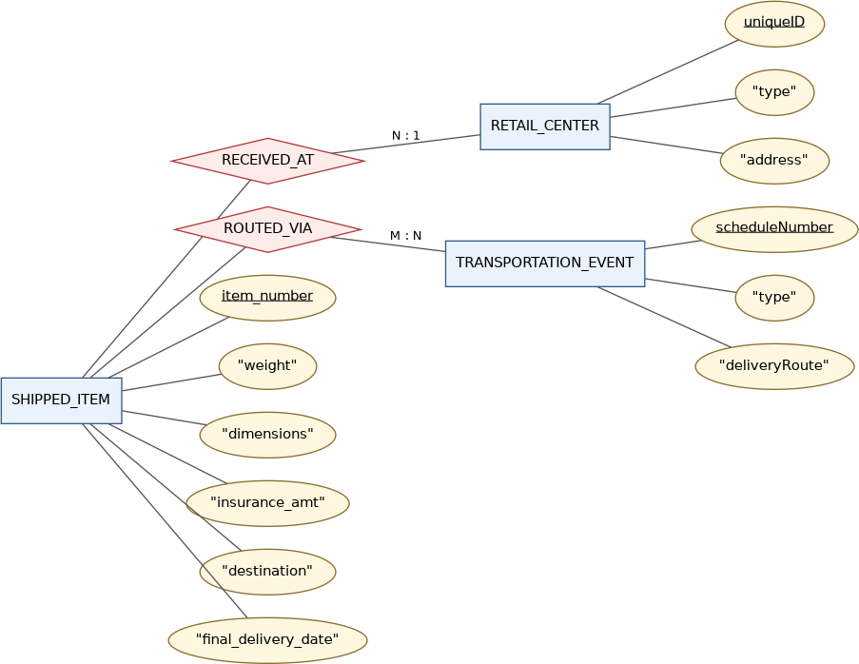

Q2. Course Management System (Exam Scheduling) Entities
- course (c-number PK, name, department)
- section — weak entity (s-number partial key, enrollment), dependent on course
- room (r-number PK, capacity, building)

Relationships
- sec_of (identifying) — course (1) : section (N)
- held_in — section (N) : room (1), attribute time

E-R Diagram
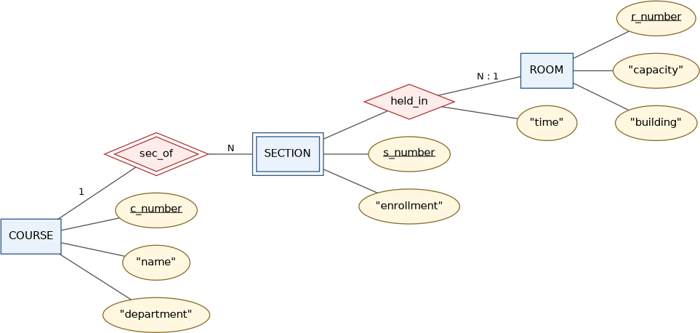

Q3. University Registrar's Office Management System Entities
- course (course_number PK, title, credits, syllabus)
- course_offering — weak entity (year, semester, section_number partial key; timings, classroom)
- student (student_id PK, name, program)
- instructor (instructor_id PK, name, department, title)

Relationships
- offering_of (identifying) — course (1) : course_offering (N)
- teaches — instructor (N) : course_offering (M)
- enrolls — student (M) : course_offering (N), attribute grade
- prereq — recursive relationship on course

E-R Diagram
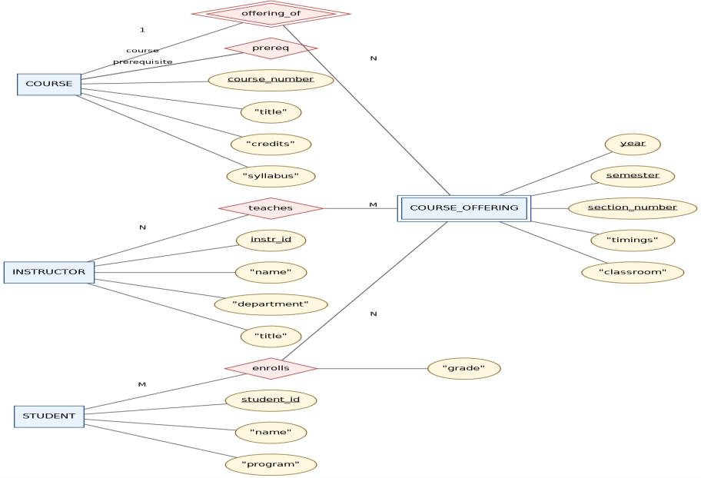

Q4. Hospital Management System Entities
- PATIENT (SS# PK, name, insurance)
- PHYSICIAN (name PK, specialization)
- TEST_LOG — weak entity dependent on PATIENT (test-name, date partial key; time)

Relationships
- doctor_patient — PATIENT (M) : PHYSICIAN (N)
- undergoes (identifying) — PATIENT (1) : TEST_LOG (N)

E-R Diagram
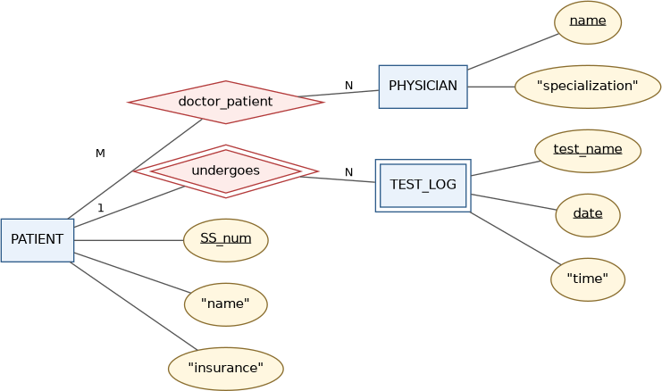

Relational Tables

Table | Attributes | Key / Notes
Patient | SS#, name, insurance | PK: SS#
Physician | name, specialization | PK: name
Test-log | SS#, test-name, date, time | PK: (SS#, test-name, date); SS# →  FK
Doctor-patient | physician-name, SS# | Composite PK; both FKs
Patient-history | SS#, test-name, date | FK → Patient

Q5. Company Project Management System Entities
- DEPARTMENT (Dname PK, Dnumber, Locations — multivalued)
- PROJECT (Pname PK, Pnumber, Plocation)
- EMPLOYEE (SSN PK, Name, Address, Salary, Sex, Bdate)
- DEPENDENT — weak entity on EMPLOYEE (Dependent_name partial key; Birthdate, Relationship)

Relationships
- manages — EMPLOYEE (1) : DEPARTMENT (1), attribute start_date
- controls — DEPARTMENT (1) : PROJECT (N)
- works_for — EMPLOYEE (N) : DEPARTMENT (1)
- works_on — EMPLOYEE (M) : PROJECT (N), attribute Hours
- supervision — recursive on EMPLOYEE (1 : N)
- dependents_of (identifying) — EMPLOYEE (1) : DEPENDENT (N)

E-R Diagram

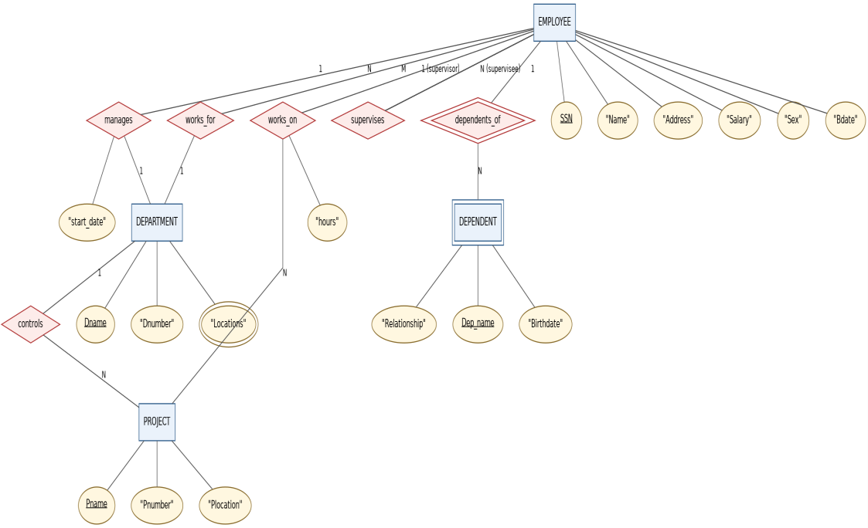

Q6. Schema, Instance, and Types of Schema Schema vs Instance
- Schema — the overall design/structure of a database (tables, attributes, data types, constraints); rarely changes. E.g. STUDENT(roll_no, name, department, year).
- Instance — the actual data stored at a given moment; changes with every insert/update/delete. E.g. {(101,"Arjun","CSE",2)}.

Logical, Physical, and View Schema

Schema Type | Describes | Example
Physical | Low-level storage — file organization,  indexing. | B+-tree indexed file on disk
Logical | Overall structure — tables, columns,  constraints. | STUDENT(roll_no PK, name,  dept, year)
View (external) | Subset a user/app is allowed to see. | App view: (roll_no, name,  dept) only

Q7. Bank Management System
Bloom's Level: BL2 – Understand | Marks: 5

Entities
- CUSTOMER (customer_id PK, name, address, phone)

- ACCOUNT (account_number PK, type, balance)
- LOAN (loan_number PK, amount)
- BRANCH (branch_name PK, branch_city, assets)

Relationships
- depositor — CUSTOMER (M) : ACCOUNT (N)
- borrower — CUSTOMER (M) : LOAN (N)
- account_branch — ACCOUNT (N) : BRANCH (1)
- loan_branch — LOAN (N) : BRANCH (1)

E-R Diagram
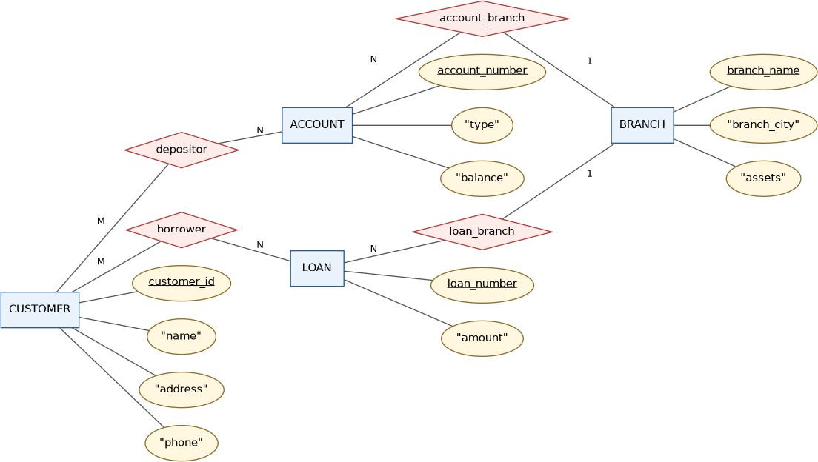

Q8. Extended E-R (EER) Model
The EER model extends the basic E-R model with three concepts to express type hierarchies and higher-level relationships:

Generalization
Bottom-up: combining entity types with common attributes into a general superclass. E.g. CAR and TRUCK → VEHICLE.

Specialization
Top-down: dividing a superclass into subclasses based on distinguishing features (subclasses inherit superclass attributes). E.g. EMPLOYEE → SECRETARY, ENGINEER, MANAGER.
- Total vs partial — every entity must (total) or need not (partial) belong to a subclass.
- Disjoint vs overlapping — entity belongs to only one (d) or possibly several (o) subclasses.

Aggregation
Treats a relationship set as a higher-level entity so it can participate in another relationship. E.g. WORKS_ON(EMPLOYEE, PROJECT) aggregated to relate with EQUIPMENT via USES.

Q9. EER Diagram for a Hospital Management System Design Overview
- PERSON — superclass (SSN, name, address); specialized (disjoint) into PATIENT and STAFF

- STAFF further specialized (disjoint) into DOCTOR (specialization) and NURSE (shift)
- PATIENT adds patient_id, insurance
- TEST_RECORD — weak entity on PATIENT (test_name, date partial key)
- Relationships: undergoes (identifying), treated_by, admitted_to

EER Diagram
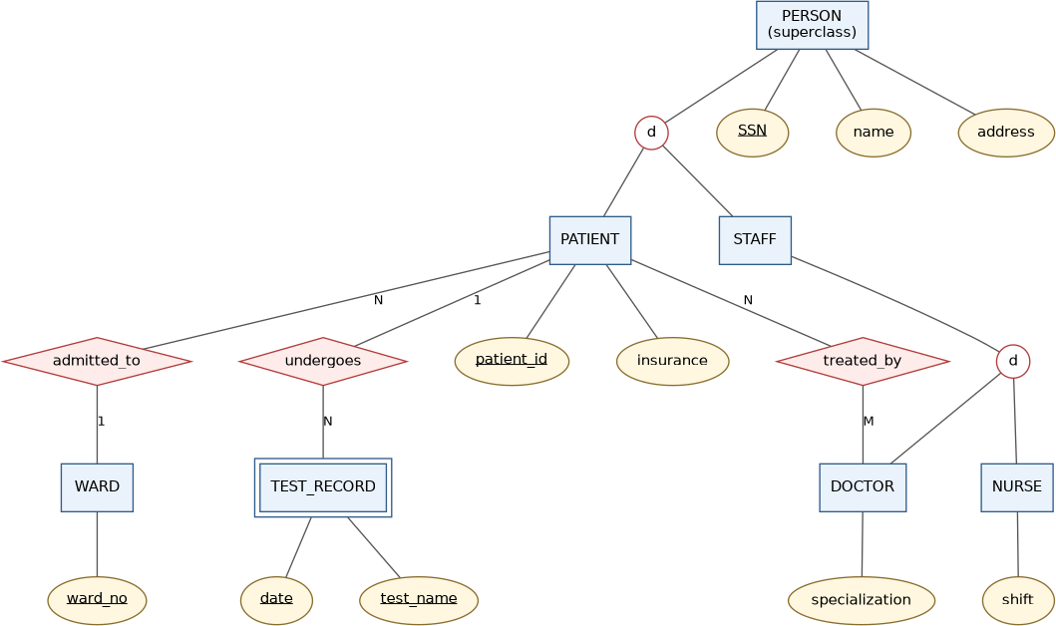

Q10. Role of the Database Administrator (DBA)
The DBA is the person/team with central control over the data and programs accessing it, responsible for the DBMS's overall management, security, and performance.

Key Responsibilities
- Schema definition (logical, physical, view)
- Storage structure and access-method definition
- Schema and storage reorganization
- Granting authorization (GRANT/REVOKE)
- Routine maintenance and backup
- Ensuring data integrity and security
- Performance monitoring and tuning
- Backup and recovery planning

